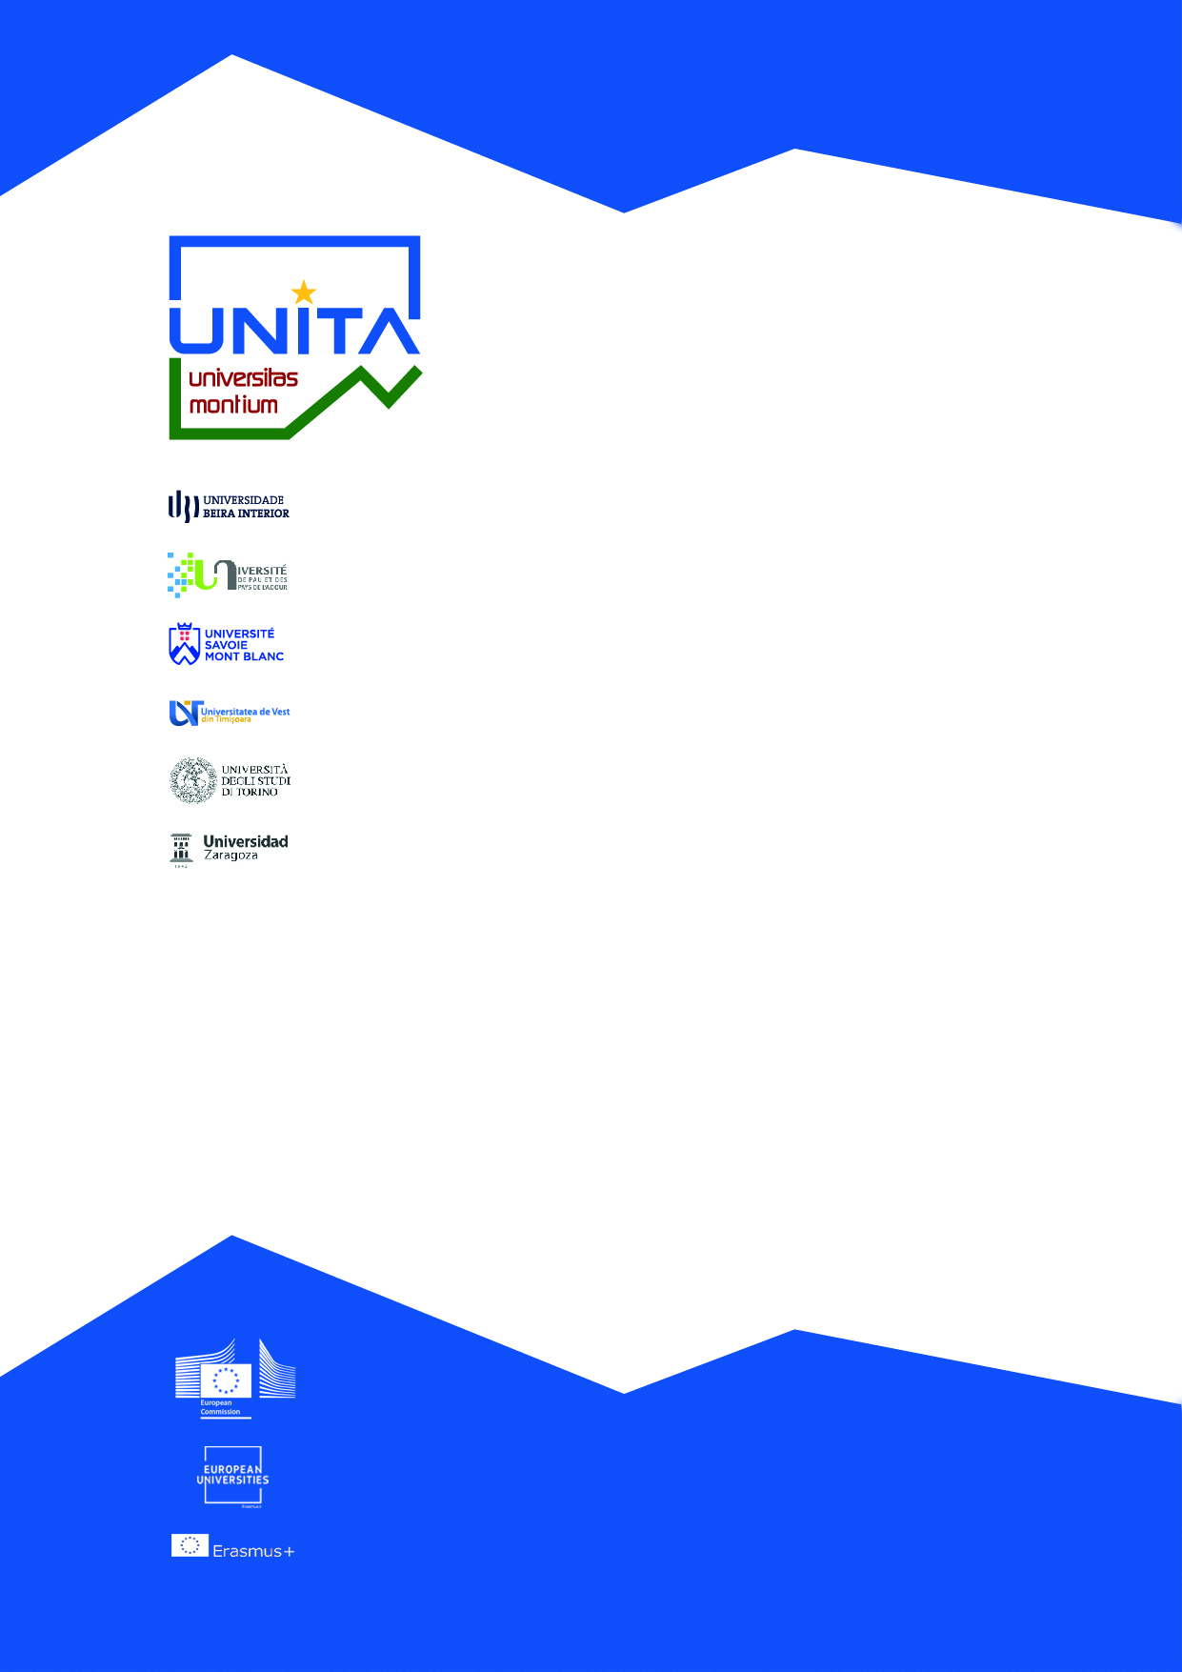

UNITA UNIVERSITIES
PhD joint-supervision

UNIZAR-UPPA
UNIZAR-UBI, USMB, UVT, UNITO

Document authors : Alexia Sanz (UNIZAR) and
Sabina Scarpellini (UNIZAR)

Zaragoza, 3rd October 2022
Strategic Call Launched by UNIZAR within their own R&D&I Program for SIX PhD student grants
The University of Zaragoza announces two public tenders for PhD students (Researchers in Training) through a PhD contract (under the Spanish Regulation: art. 21 Law 14/2011, of June 1, on Science, Technology and Innovation, modified by art. 19 of Law 17/ 2022 of September 5).
Financing : Vice-Rectorate for Scientific Policy (UNIZAR)
Period for submitting applications: From 09/24/2022 to 10/13/2022.

- Strategic call of UNIZAR within their own Program of R&D&I of THREE PhD grants in the framework of the collaborative agreement UNIZAR-UPPA
PARTICIPATING UNIVERSITIES : University of Zaragoza (UNIZAR) and the University of Pau et des Pays de l'Adour (UPPA).
PURPOSE : Call for three PhD grants under the joint-supervision agreement UNIZAR-UPPA in the framework of the UNITA European Campus .
Deadline for submitting applications: 10/13/2022.
Requirements
- Bachelor's degree, engineer, architect, university graduate (300 credits).
- Be enrolled or admitted to a doctoral program at the University of Zaragoza, in the academic year 2021 - 2022 or following.
- In the case of degrees obtained abroad, the provisions of Base 2.1.1 will apply.
- Have an average grade equal to or greater than 6 points over 10 in the academic record.
- Not be in possession of a PhD degree, issued by any university, Spanish or foreign.

Main tasks
Completion of a PhD thesis under joint supervision between the University of Zaragoza and the University of Pau et des Pays de l'Adour.
Specific conditions:
a) The PhD thesis project proposal may be written in English and/or in the official languages of the two universities, that is, in Spanish or French.
b) The selected candidates will be enrolled under a 3 years contract.
Contract: 3 years
Dedication: Full time 37.5 hours/week.
Information at:
http://www.unizar.es/gobierno/gerente/vg_investigacion/documents/Convocatoria_PI_PRD_2022_003.pdf
Published in BOA nº 186 of 09/23/2022. Procedure no. PI-PRD/2022-003.

- Strategic call of UNIZAR for THREE PhD grants in the framework of the UNITA European Campus

PURPOSE : Call for three PhD grants in the framework of the UNITA European Campus .
PARTICIPATING UNIVERSITIES: University of Zaragoza (UNIZAR) and the Universities of Turin (Italy), Savoie Montblanc (France), Beira Interior (Portugal) and West of Timisoara (Romania).
Period for submitting applications: From 09/24/2022 to 10/13/2022.
Requirements
- Bachelor's degree, engineer, architect, university graduate (300 credits).
- Be enrolled or admitted to a doctoral program at the University of Zaragoza, in the academic year 2021 - 2022 or following.
- In the case of degrees obtained abroad, the provisions of Base 2.1.1 will apply.
- Have an average grade equal to or greater than 6 points over 10 in the academic record.
- Not be in possession of a PhD degree, issued by any university, Spanish or foreign.
Main tasks
Completion of a PhD thesis under joint supervision of two of the mentioned Universities , preferably, in one of the UNITA thematic areas: Cultural Heritage, Renewable Energy or Circular Economy.
Specific conditions
a) The doctoral thesis project proposals may be written in English and/or in the official languages of the universities in joint-supervision.
b) The selected candidates will be enrolled under a 3 years contract.
c) The doctoral candidate must spend at least 9 months as visiting PhD student in another university of the UNITA consortium, and at least 6 months have to be spent at the University of the joint-supervision.
Contract: 3 years
Dedication: Full time 37.5 hours/week.
Deadline: 10/13/2022.
Information at: BOA nº 186 of 09/23/2022. Procedure no. PI-PRD/2022-004.
http://www.unizar.es/gobierno/gerente/vg_investigacion/documents/Convocatoria_PI_PRD_2022_004.pdf

